Report Portfolio Item 1 – Summary and Critical Review – Tomasz Przybylski K1602155

The article I will be considering for the Report Portfolio: *Blockchain: background, challenges and legal issues.* Written by John McKinlay, Duncan Pithouse, John McGonagle and Jessice Sanders and published on the 5th of June 2017 [1]

Article Summary:

The article talks about the challenges of successfully integrating Blockchain technologies into existing business practices and seeks to ask the question “what are the key issues in relation to blockchain and distributed ledger technology?” (McKinlay 2017). As said by McKinley, “In its simplest form, blockchain is a decentralised technology or distributed ledger on which transactions are anonymously recorded.” It is a very controversial technology and this article helps to shed some light on why.

The article outlines many different arguments as to what the challenges are and the main arguments can be summarised as follows:

“Security comes (only) with simplicity” – The argument is that blockchain is said to be virtually unhackable, but in reality, this strength only applies to systems with a large enough number of “nodes” and as such, cannot be developed for bespoke usage or modified

“Performance challenges” – Blockchain databases grow very quickly and may be unsuitable for certain types of transactions

“Early adoption” – The technology is very new and as such is not trusted enough to be implemented in certain situations

“Jurisdiction” – The technology can (and is) linked all around the world and so it is difficult to pinpoint a jurisdiction that could deal with any legal issues that arise. It could also be difficult to locate the source of a fraudulent transaction. This idea is continued in the next argument, “Intellectual property”

“Data privacy” – Data cannot be altered or erased (right to be forgotten?) and transactions are completely transparent, which is “incompatible with the needs of the banking sector” (McKinlay 2017)

Critical Review:

The article does a good job of answer the question it posed at the beginning. Of course, it does not explore all the possibilities and could include some more specifics and details, however I believe it does a good job of informing someone who would not know much about blockchain or computing technology in general, while still proving valuable to someone who has previous experience in either field. The diagram included in the article is also very interesting and could help in understanding the idea behind how Blockchain works. The arguments mentioned are very interesting and clearly outline

I think the conclusion of the article could be improved, and some things I found lacking from the article were any kinds of statistics or links/mentions to other pieces with more and/or continuing information. I would have also liked to see the article explore the moral side of the technology, and seeing how it compares to the legal challenges

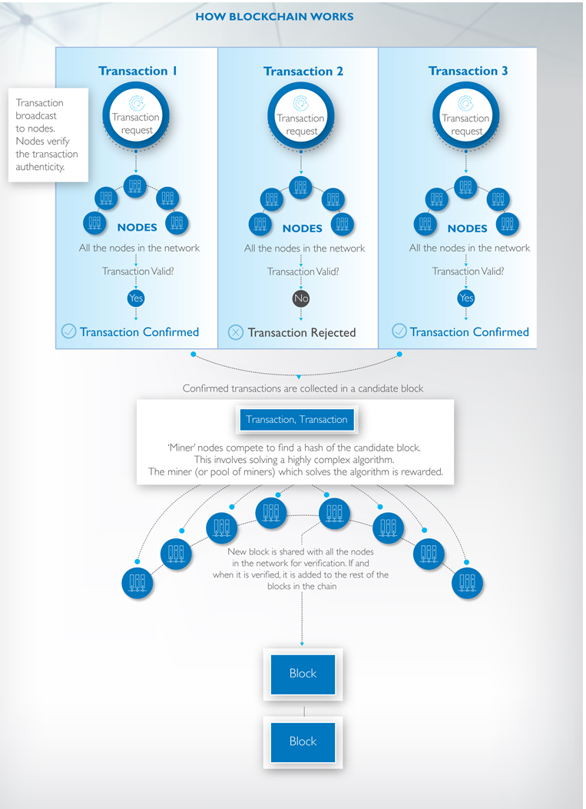

[1] McKinlay, J.*et al.*(2017) ***Blockchain: background, challenges and legal issues****.*Available at: <https://www.dlapiper.com/en/australia/insights/publications/2017/06/blockchain-background-challenges-legal-issues/> (Accessed: 16/10).